Roller Coaster Rankings & Statistics – Extended Analysis

Problem Statement
Roller coasters are ranked annually by the Golden Ticket Awards (wood & steel, 2013–2018) and described by physical attributes in a 2,802-row Captain Coaster dataset. The goal is to visualize ranking trajectories, explore distributions of speed/height/length/inversions, discover manufacturer & seating patterns, and test how sensitive “best coaster” conclusions are to analysis choices (filters, weights).

Solution Strategy
1) Load & inspect rankings + stats CSVs. 2) Parameterized line plots for 1 / 2 / top-n coasters (with optional park filter). 3) Histograms, park inversion bars, status pie, speed–height scatter. 4) Group-by analysis of seating types & manufacturers. 5) Correlation heatmap. 6) Alternate implementations (seaborn, method chaining, pivot). 7) Simulation: vary top-n, height thresholds, and synthetic popularity-score weights.

Solution (Selected Visuals)
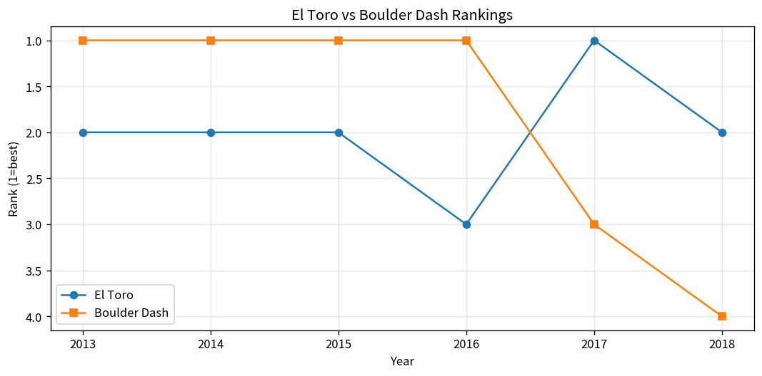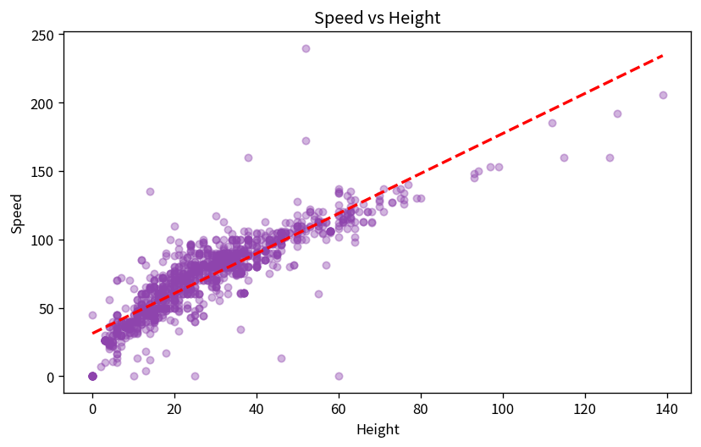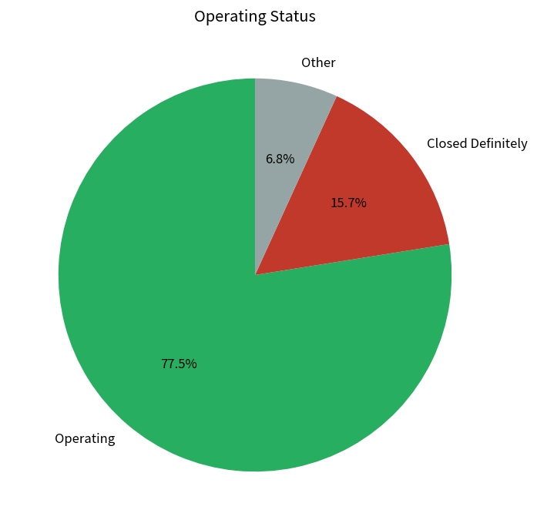
El Toro vs Boulder Dash rankings | Speed vs Height (filtered) | Operating status (~77 % operating)
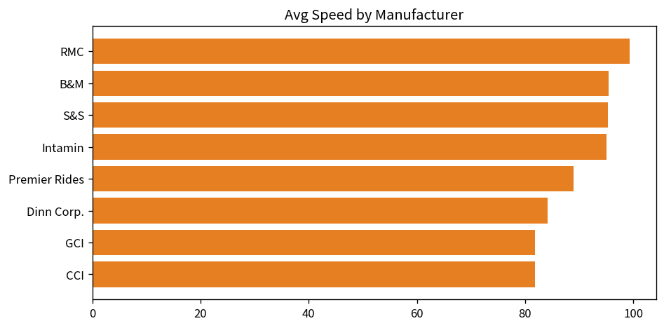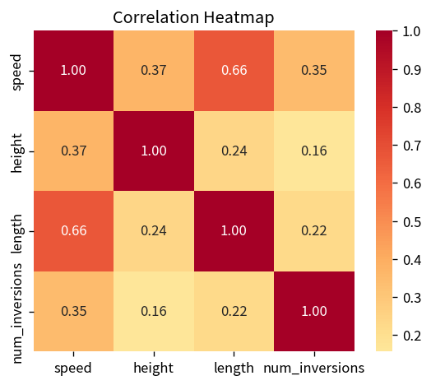
Manufacturer avg speed (RMC / B&M / Intamin lead) | Feature correlations (speed–length 0.66)

Key Takeaways
• Rankings: Millennium Force dominates steel longevity; Fury 325 rocketed to #1 after 2015. Boulder Dash / Phoenix / El Toro rule wood. Name collisions require a park filter.
• Physics link: After removing extreme height outliers, height–speed correlation rises to ~0.88; overall unfiltered corr ≈ 0.37. Speed also correlates strongly with length (0.66).
• Industry patterns: RMC, B&M, S&S, Intamin specialize in high-speed coasters; wooden coasters almost never invert (avg 0.08 vs 0.82 steel). Floorless / Wing seating associates with higher average speeds.
• Simulation: Changing synthetic-score weights (speed vs height vs inversions) completely reorders the “top 10”; metric choice is not neutral. Height-filter threshold also shifts measured correlations.
• Status: ≈77 % of catalogued coasters remain operating; the rest are closed, announced, under construction or rumored.

